**FUNCTIONAL REQUIREMENT OF INVENTORY MANAGEMENT FOR RETAILER**

**Key Requirements**

Elaborately discussed below are some of the most important inventory management system requirements and features:

**1. Inventory Management**

Obviously, inventory management capabilities will be at the core of any inventory management system, but here’s what these functionalities can do for you.

You can centralize your most basic and necessary warehouse functions and access inventory details like stock levels, product history and other product specifications. You can break down data silos by syncing data and offering collaborative inventory, which allows vendors to manage your inventory remotely.

Vendor managed inventory (VMI) is a great solution for those in long-term business relationships.

You may also be interested in automatic shortage reports so you can respond to any ensuing issues as quickly as possible. Don’t wait until your phone is ringing off the hook to deal with unfortunate inventory mishaps.

Alerts and reports give you the agency and response time needed to handle such events. Inventory control can also help you build an eCommerce presence.

* Product Categorization
* Product Measurement
* Product History
* Stock Inquiries
* Cycle Counting
* Collaborative Inventory
* Automatic Stock-out Reports
* Vendor Managed Inventory
* E-commerce

**2. Inventory Tracking**

From accessing updated stock levels and their locations to setting inventory valuation and counting turnover, tracking your inventory is important at every stage. Many systems allow you to track your inventory by serial numbers, RFID tags, barcodes and other IDs.

Inventory tracking helps sync orders, provides complete visibility of your product life cycle, enables multi-location tracking, prevents shortages and promotes efficient inventory forecasting.

* Product Tracking
* Advanced Inventory Tagging
* Audit Trail

**3. Transfer Management**

Businesses that manage multiple sites have the advantage of moving their product to where it’s most valuable. Bundling or kitting your products can be attractive to customers, especially during certain times of the year. Transfer management can help guide and direct your workforce to reduce any confusion and streamline their efforts.

* Multi-Location Tracking
* Stock Transfer
* Order Picking
* Kitting and Product Bundling
* Voice Picking
* Pick-To-Light (PTL)

**4. Purchasing**

Purchasing is an incredibly important feature to any warehouse that heavily relies on vendor goods to produce their own. This feature mainly works to help users create and manage purchase orders.

Many systems include templates that automatically populate with existing data from other parts of the system. Users may also find it helpful to email suppliers directly from their inventory control system, which reduces the amount of time spent switching screens.

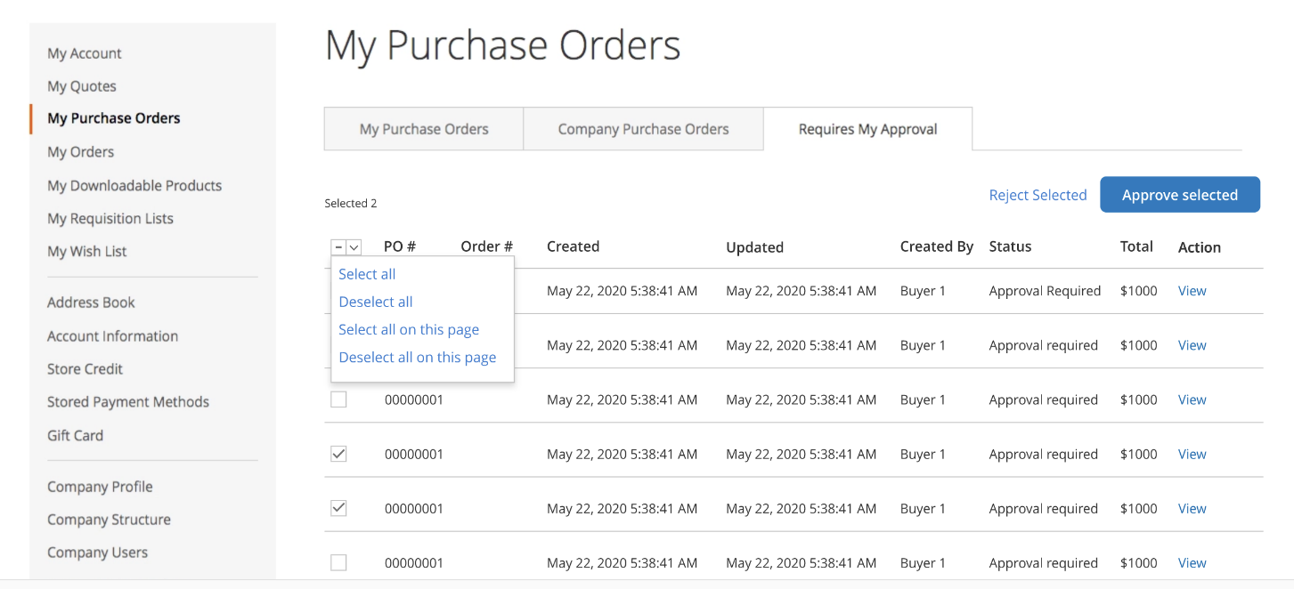

Some inventory software solutions allow users to add items to purchase orders through barcode scanners. You may wish to opt for an inventory system that automatically generates purchase orders when an item is low in stock to prevent a stock outage. Purchasing also involves receiving partial orders and tracking backorders.

* Purchase Order
* Bulk Purchase Orders
* Partial Receiving
* Supplier Management
* Back-ordering

**5. Shipping**

From labelling to multi-carrier shipping and dispatching orders as multiple shipments, ensure your customers get their in-stock goods quickly with back-ordered items sent at a later time. Some systems allow you to ship by lot IDs, which is great for FIFO and LIFO shipments.

Most vendors offer solutions to help you manage your sales orders. These tools allow users to customize pricing, send quotes, track orders and manage returns.

Some advanced systems sync orders with inventory levels, mark items for shipment, support multichannel sales and make auto-adjustments to maintain profitability. Order management systems are an essential feature of increasing and maintaining customer satisfaction.

* Labelling
* Multi-carrier Shipping
* Multiple Shipment Orders
* Shipment by ID

**6. Reporting & Analytics**

Make your business thrive using inventory metrics and KPIs to evaluate patterns in your processes to forecast future demand and sales. Demand forecasting is a way to reduce safety stock and carrying costs.

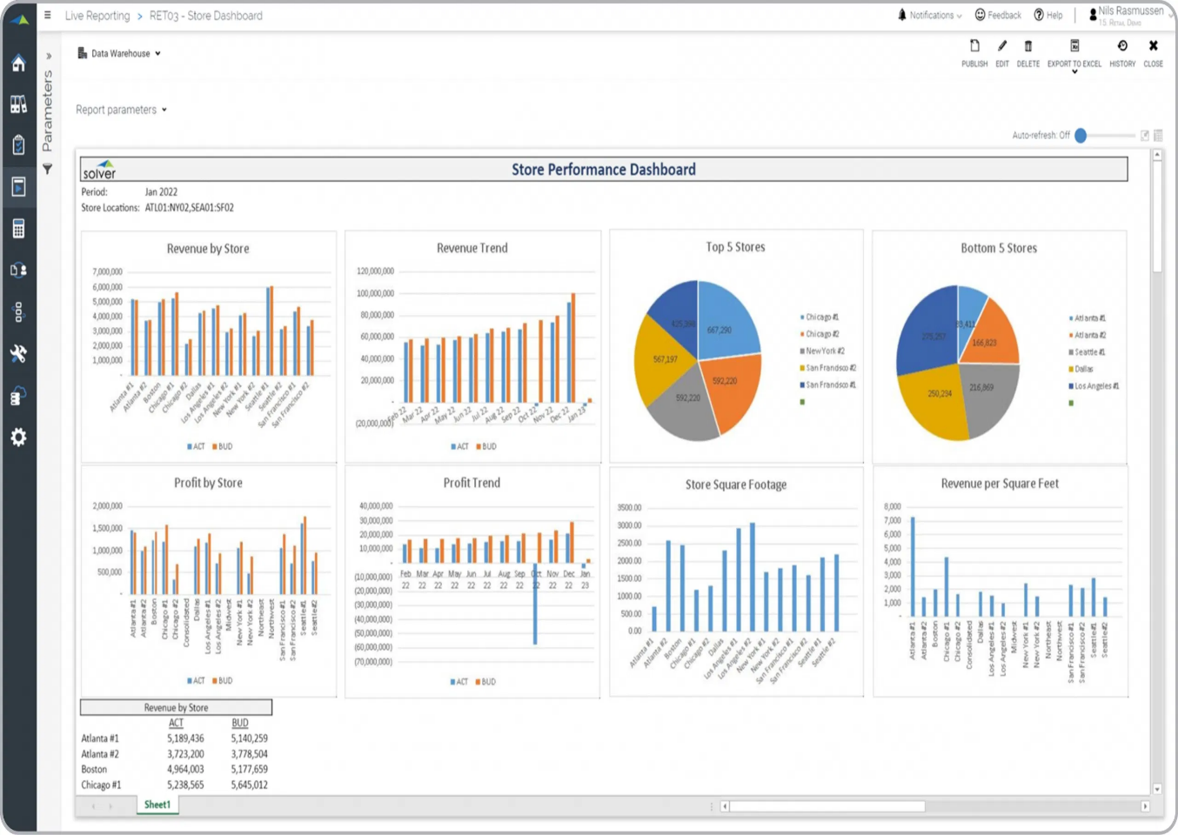

Keeping inventory around simply for safety’s sake is no longer necessary when you have great insights into how much you’ll actually need.

* Dashboards
* Customized Reports
* Report Integration
* Drill-down

**7. Deployment**

Since not every system offers both deployment methods, you’ll have to consider which is best for your company before you shortlist. Cloud-based inventory products typically have fewer sunk costs, offer better visibility and maintain a backup of your data. But many companies prefer on-premise due to privacy concerns or industry compliance standards.

There are also several types of cloud deployment methods like SaaS, PaaS and IaaS. Some products may offer you deployment options that are more specified, so it’s important to understand the differences.

* On-premise
* Cloud-based

**8. Mobile Support**

This aspect affects what hardware you’ll be managing your processes on and if you’ll be able to do it remotely. Many systems offer a mobile website, which enables users to access the system from any desktop. If you utilize tablets, phones or other mobile devices, check to see if a vendor offers a native application.



Mobile support is often OS-specific, so it’s important to keep that in mind as well. While most vendors try to support all popular platforms, it’s not a universal concern. So, it’s always important that the inventory app you invest in can run on your existing hardware.

* Native Application
* Mobile Website
* Operating System

**9. Integration**

If you use multiple systems for your business, it’s important they integrate well. It could be beneficial to integrate your other supply chain management systems, CRM platforms.

Centralizing business functions that used to exist only as separate processes is one of the greatest benefits of business software. If your systems can’t share information freely, you’re not getting the most from them.

* Integration and Synchronization
* API/Web Service

**10. Demand Forecasting**

Do you wish to minimize stockouts or overstocking? Reduce inventory holding costs and product waste? Then demand forecasting is the way to go. This factor helps you use sales histories, calculate average lead time, analyse trends, calculate safety stock and set reorder points to predict inventory levels.

* Price Policy Formulation
* Finance Arrangement
* Sales Control

**11. Drop shipping**

Are you looking to open an online store but lack the budget to maintain inventory? Drop shipping is an efficient way to generate passive income with minimized shipping rates. Collaborate with third-party vendors for drop shipping order fulfilment and preventing stockouts.

* Order and Fulfilment Automation
* Sourcing Management
* Manage Listings
* Supplier Management

**12. Just in Time (JIT) Inventory Management**

The goal of just-in-time inventory management is to possess a minimum quantity of inventory to meet demand. You can lower inventory costs, eliminate the risk of owning dead stocks and product loss, source locally, maximize inventory turnover ratios, and overall boost your company’s ROI.

* Inventory Forecasting
* Barcode and Tagging
* Inventory Alerts

**13. First In, First Out (FIFO)**

The FIFO strategy in inventory is a simple bookkeeping method used to calculate the cost of goods sold (COGS), where you sell the oldest products in your inventory first. FIFO is primarily used to track perishable products like food, where there is a constant rotation of items for improved safety.

* Inventory Valuation
* Bookkeeping